Result Analysis of Class XII (Session – 2017-18)
Total Appeared | Total Passed | Fail and Comp. | Overall Pass Percentage | 33 % to 44.9 % | 45 % to 59.9 % | 60 to 74.9 % | 75 to 89.9 % | 90 to 100 %
71 | 67 | 4 | 94.37 | 2 | 9 | 33 | 24 | 3

A1 | A2 | B1 | B2 | C1 | C2 | D1 | D2 | E | Total Grades | NxW | PI | Mean
29 | 45 | 70 | 48 | 55 | 58 | 45 | 18 | 8 | 376 | 1709 | 60.18 | 369.6

KVS Regional Office Jabalpur Merit List (Session – 2017-18)
Ku. Vandana Budhrani topper of XII Commerce features in the Merit List of KVS Regional Office Jabalpur.
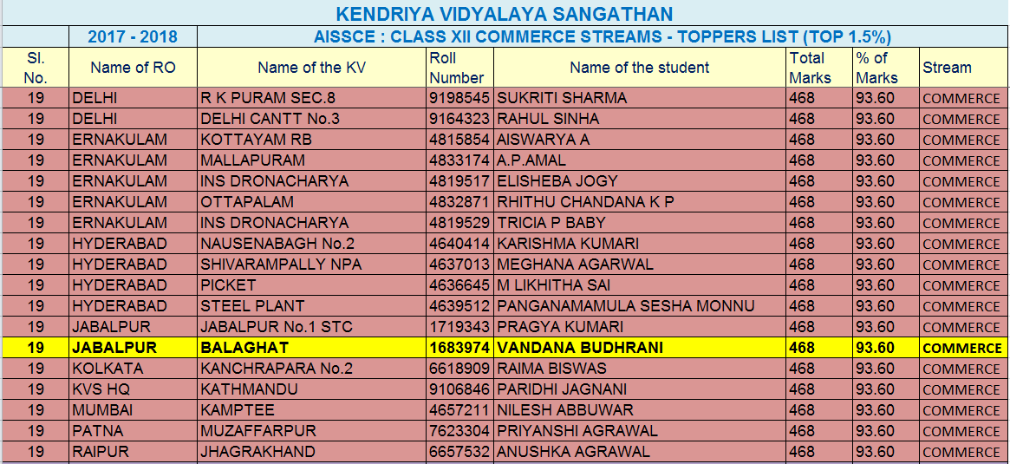

Result Analysis of Class X (Session – 2017-18)
Appeared | Passed | Fail and Comp. | ABST | Pass % | 0 to 32.9 | 33 % to 44.9 % | 45 % to 59.9 % | 60 to 74.9 % | 75 to 89.9 % | 90 to 100 %
92 | 72 | 20 | 0 | 78.26 | 3 | 17 | 30 | 19 | 22 | 1

A1 | A2 | B1 | B2 | C1 | C2 | D1 | D2 | E | Grade Count | NxW | PI | Mean
28 | 51 | 54 | 42 | 60 | 55 | 69 | 72 | 29 | 460 | 1730 | 47.01 | 298.58

Internal Examination (Session – 2017-18)
Result Primary Section
Class | Appeared | Passed | Pass Percentage
I | 76 | 76 | 100 %
II | 83 | 83 | 100 %
III | 87 | 87 | 100 %
IV | 86 | 86 | 100 %
V | 82 | 82 | 100 %

Middle Section
Class | Appeared | Passed | EIOP | Pass Percentage
VI | 96 | 70 | 26 | 100
VII | 98 | 69 | 29 | 100
VIII | 94 | 67 | 27 | 100

Class - IX
Result Analysis - Subject Wise (Session – 2017-18)
 | HINDI | ENGLISH | MATHS | SCIENCE | SO,SCI | SANSKRIT | OVERALL
TOTAL REGISTERED | 65 | 86 | 86 | 86 | 86 | 21 | 86
TOTAL APPEARED | 65 | 86 | 86 | 86 | 86 | 21 | 86
PASSED | 63 | 62 | 60 | 61 | 73 | 21 | 55
PASS % | 96.92 | 72.09 | 69.77 | 70.93 | 84.88 | 100 | 63.95
90 AND ABOVE (A1) | 24 | 0 | 8 | 5 | 14 | 2 | 3
75 TO 90 (A2) | 24 | 6 | 10 | 14 | 13 | 8 | 18
60 TO 75 (B) | 7 | 18 | 12 | 12 | 20 | 10 | 20
45 TO 60 (C) | 6 | 20 | 15 | 15 | 14 | 1 | 14
33 TO 45 (D) | 2 | 18 | 15 | 15 | 12 | 0 | 0
<33 (E) | 2 | 24 | 26 | 25 | 13 | 0 | 31
TOTAL | 65 | 86 | 86 | 86 | 86 | 21 | 86
PI | 84.62 | 46.8 | 49.56 | 50.15 | 64.1 | 81.55 | 49.42

Class - XI
Result Analysis - Subject Wise (Session – 2017-18)
 | HINDI | ENGLISH | MATHS | PHY | CHEM | BIO | ACC | BST | ECO | CS | IP | PHE | OVERALL
TOTAL REGISTERED | 53 | 92 | 38 | 53 | 53 | 21 | 39 | 39 | 39 | 22 | 11 | 35 | 92
TOTAL APPEARED | 53 | 92 | 38 | 53 | 53 | 21 | 39 | 39 | 39 | 22 | 11 | 35 | 92
PASSED | 52 | 87 | 36 | 44 | 44 | 21 | 26 | 29 | 35 | 21 | 8 | 35 | 65
PASS % | 98.1 | 94.6 | 94.7 | 83 | 83 | 100 | 66.7 | 74.4 | 89.7 | 95.5 | 72.7 | 100 | 70.7
90 AND ABOVE (A1) | 4 | 2 | 3 | 4 | 2 | 1 | 0 | 0 | 2 | 2 | 0 | 1 | 3
75 TO 90 (A2) | 26 | 19 | 7 | 4 | 6 | 1 | 2 | 3 | 5 | 7 | 1 | 17 | 8
60 TO 75 (B) | 16 | 27 | 8 | 9 | 8 | 7 | 3 | 5 | 13 | 5 | 2 | 17 | 25
45 TO 60 (C) | 6 | 27 | 9 | 17 | 11 | 10 | 9 | 11 | 9 | 6 | 5 | 0 | 27
33 TO 45 (D) | 0 | 12 | 9 | 10 | 17 | 2 | 12 | 10 | 6 | 1 | 0 | 0 | 2
<33 (E) | 1 | 5 | 2 | 9 | 9 | 0 | 13 | 10 | 4 | 1 | 3 | 0 | 27
TOTAL | 53 | 92 | 38 | 53 | 53 | 21 | 39 | 39 | 39 | 22 | 11 | 35 | 92
PI | 80.19 | 67.12 | 66.45 | 56.37 | 54.01 | 68.45 | 40.06 | 46.79 | 63.46 | 73.3 | 50 |  | 50.68
SUBJECT TEACHER | MR.V. CHATURWEDI | MR. S. BODELE | MR. R. AGEAWAL | MR.T.S. RAHANGDALE | MS. M. R. DOLARE | MRS. A. AGRAWAL | MR. S. GUPTA | MR. S. GUPTA | MRS. SHIKHA GUPTA | MR.S.K.BISEN | MR.S.K.BISEN

